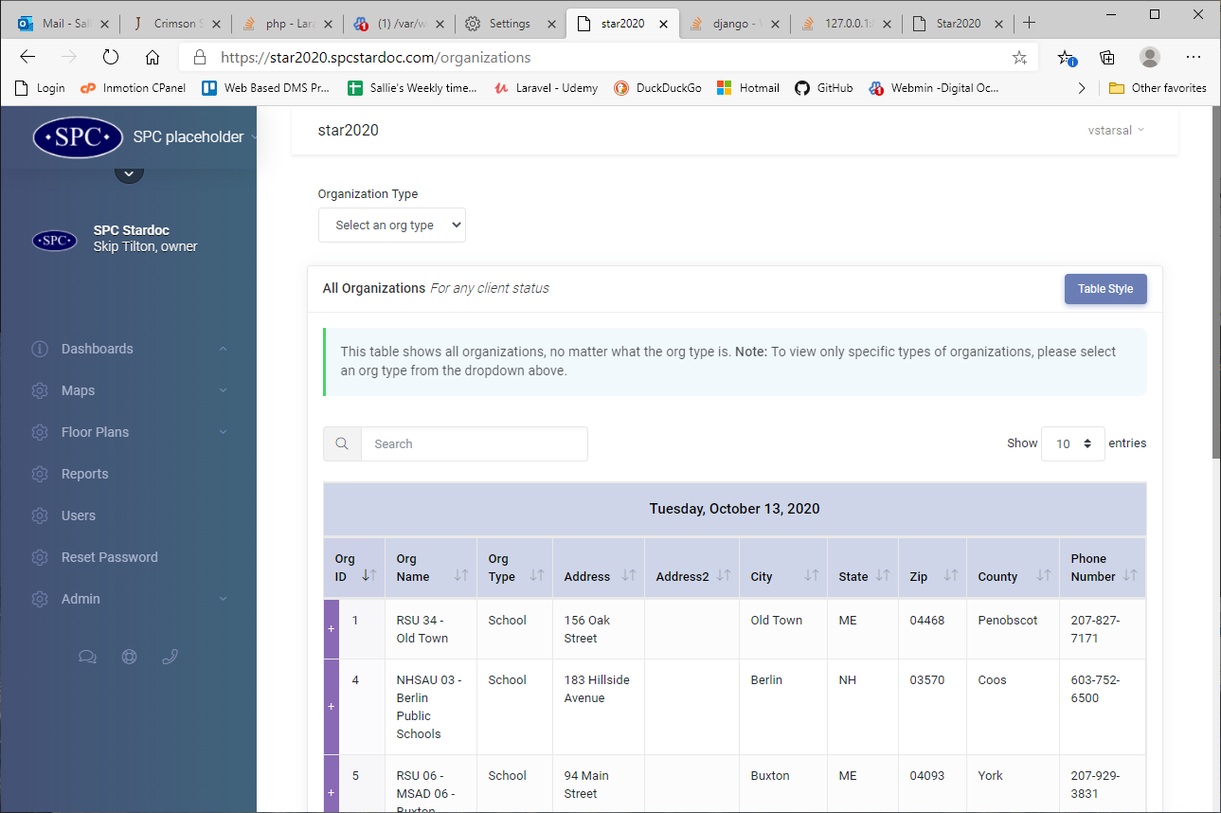
Selecting an org type at this url
Brings me to the localhost url
The fix ended up being that I had to create a route in web.php because the automatically registered routes in route:list apparently were not working.
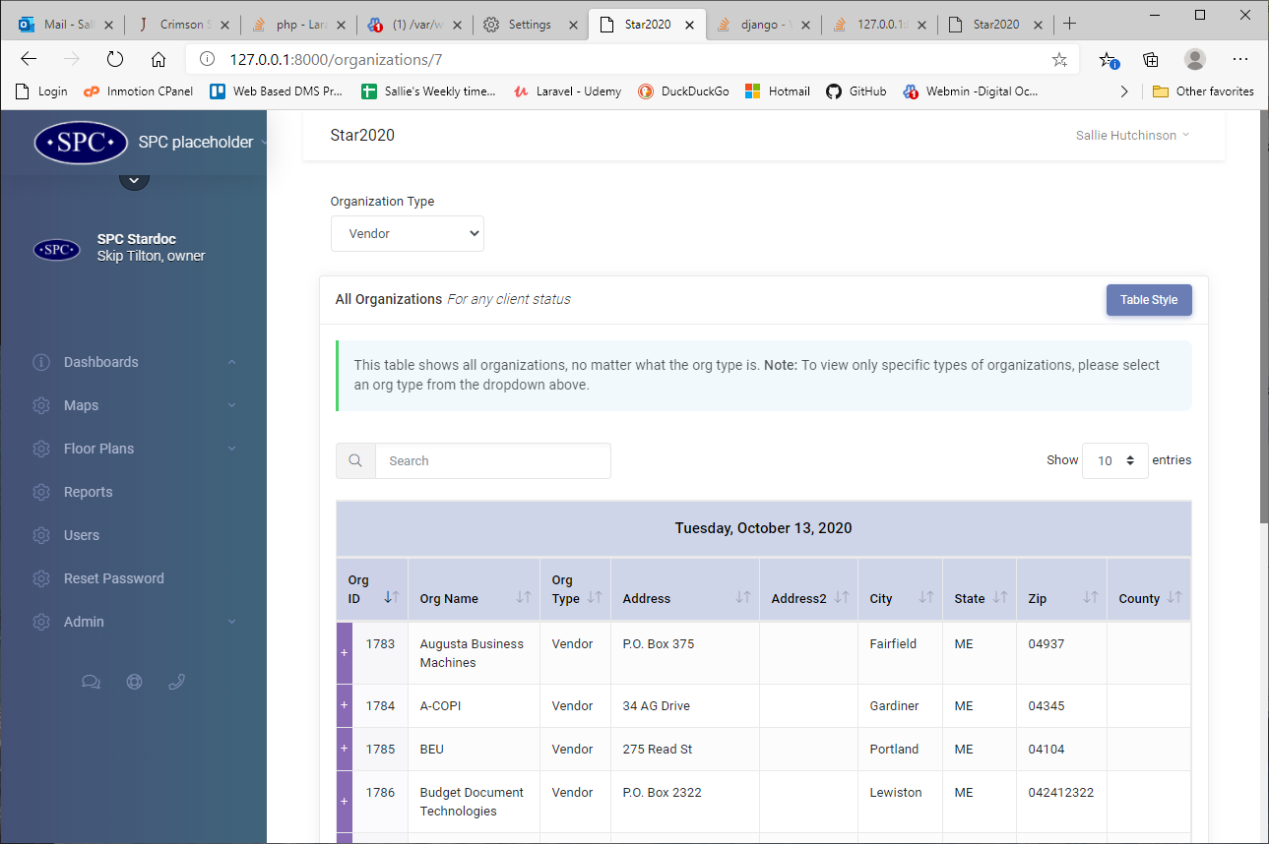
Because of the function in myScripts
