Work to restart star2020 laravel site

To Do
- Investigate errors on Bob's site - Site was still pointed to Digital Ocean. Bob had to go into his cPanel AMP to point the nameservers to the correct urls for reseller accounts.
- See about placing on spc's inmotion host
We are using laravel framework 8.6.0
- Laravel is NOT automatically updated
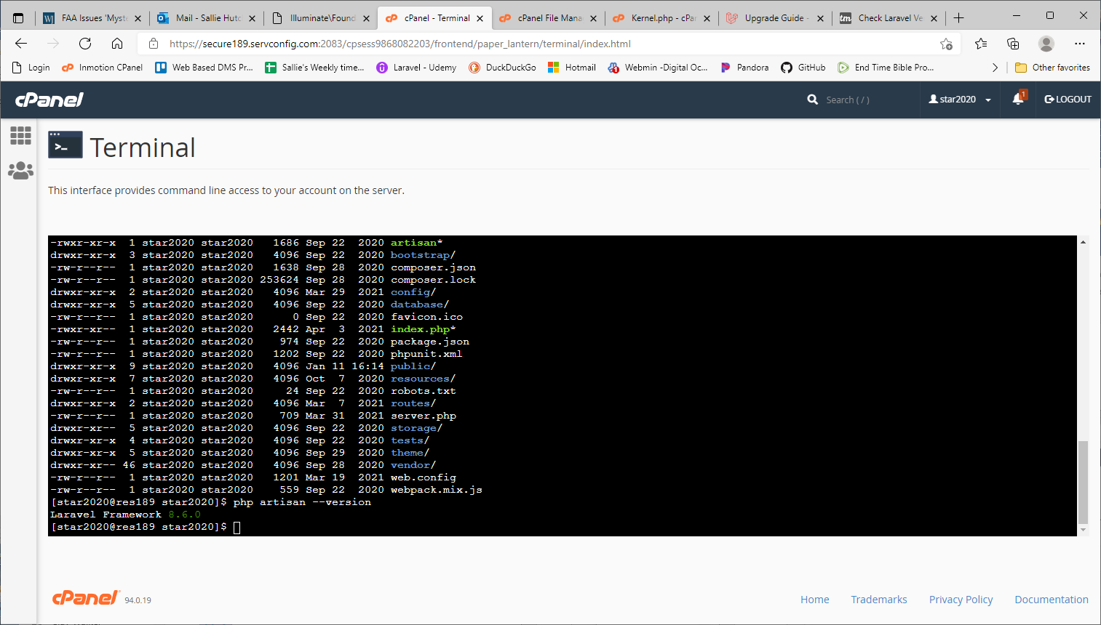

laravel 8.0 requires php 7.3, we have version 7.2.34
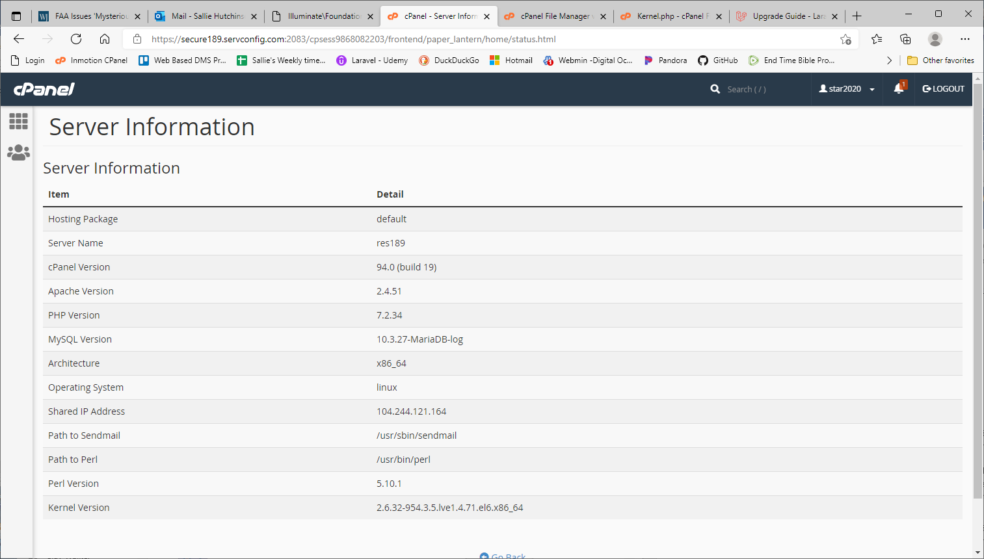
This exception was apparently because we really had no space left on the device. We no longer had a digitalOcean account, which is where we were pointed to.
ErrorException
fwrite(): write of 1913 bytes failed with errno=28 No space left on device

Illuminate\Foundation\Bootstrap\HandleExceptions::handleError
vendor/monolog/monolog/src/Monolog/Handler/StreamHandler.php:134
protected function streamWrite($stream, array $record): void
{
fwrite($stream, (string) $record['formatted']);
}

The organization page, when selecting the org_type, sends to the wrong url http://star2020.spcstardoc.com.
The meter page, when the year is selected, sends to the wrong url http://star2020.spcstardoc.com also.
The correct url is http://star2020.net/star2020
This issue was because the page_direct function in custom/js/myScripts still pointed to the old url. I was unable to search the file contents on inmotion's gui, so I went to the command line and found the old url.

