Migrating Laravel site to Inmotion
https://stackoverflow.com/questions/25418156/how-to-serve-index-html-with-laravel
https://dev.to/asapabedi/deploying-laravel-5-applications-on-shared-hosting-without-the-use-of-ssh--16a6
https://stackoverflow.com/questions/53748977/laravel-php-parse-error-syntax-error-unexpected-in-vendor-laravel-framew
https://stackoverflow.com/questions/31805814/how-to-set-the-base-path-in-laravel-5
https://www.youtube.com/watch?v=6g8G3YQtQt4 - - Deploy Laravel To Shared Hosting The Easy Way
https://www.inmotionhosting.com/support/domain-names/changing-the-document-root-with-root-access/
https://stackoverflow.com/questions/19283155/deploy-laravel-4-app-in-a-subdomain
https://laracasts.com/discuss/channels/general-discussion/where-do-you-set-public-directory-laravel-5

https://www.webhostinghub.com/help/learn/website/managing-files/directory-to-upload-files

What Directory should I Upload my Files to?
Written by Brad Markle
Views: 372,305
Published: Mar 18, 2016
Comments: 53
When you are ready to upload your website, in order for it to display on the Internet the files must be placed in the correct folder. By default, your primary domain document root is public_html. You can change the Directory Index of your site by modifying the .htaccess file.

What is the Document Root?

Your Main Domain
All domain names in your account have a document root. The document root is the folder that stores the files for your website. The document root for your main domain name is the public_html folder. When you are ready to upload your website, the files will go into the public_html folder. Once you have uploaded an index page, it will over-ride the default "Hello There!" page that accounts show upon sign-up.

Addon and Sub Domains
When you add additional domains to your account, it will create a folder in your public_html folder for that domain. With a subdomain the folder will be called the same name as the subdomain, for example public_html/subdomain. For an Addon Domain, by default it will create a folder in your public_html folder with the same name as the Addon Domain. If you would like you can change the document root for your Addon Domain when it is created to a different folder.

What is a Directory Index?
The directory index is the first file the server loads and by default will be the index file within the document root of the domain (the public_html folder if it is your primary domain). Our servers always load the file called "index" if your domain is typed into the browser, first looking for index.htm, then index.html, and finally index.php. When your account is first created, we also place the default.htm file (the default "Hello There!" page) in your account that will load if no index files are found. If there is no index or default file in your folder, then the website will not load unless the directory index is modified.

Changing the directory index
Some website design applications will name the home page something other than index. For example, the application may name your homepage Welcome.html or Home.html. If your application does this, you will need to modify your site so that the directory index matches the name of your website's first page. You can do this using a .htaccess file.
In the following example we will assume you want your domain to point to Welcome.html when it is visited in a browser. We need to update the .htaccess file so that the server will load Welcome.html first. Open (or create) the .htaccess file in your domain's document root and add the following line: DirectoryIndex Welcome.html. Once that is added, when your domain is visited that page will be loaded first. Please note that our servers are case sensitive when adding the new directory index.

Directory Structure
When uploading files with either an FTP program or a site design program such as Dreamweaver, it is important to keep in mind that any folders you upload to your account will become additional folders in your directory structure. For instance, if you're uploading site files for your main domain name and you are uploading a folder named images, then the path would be public_html/images/ when viewing the folders/files in either FTP or cPanel File Manager. If you want to access that folder from your website, the path would be yourdomainame.com/images. Here is a helpful link to our guide on How to Manage Files on Your Server.
If you ever see any broken links or images on your site, one of the first things you'll want to check is where the link or image is pointed to. You can hover over a link with your mouse to see the path it is pointed to. To find out where an image is pointed to right click the broken image and select either View Image Info, Properties, Copy image url or something similar (depending on your browser and version). Once you have the path, double check that the document or image is in the folder your link or image is pointed to.

https://www.digitalocean.com/docs/droplets/how-to/add-ssh-keys/create-with-putty/
https://www.digitalocean.com/community/tutorials/how-to-install-and-configure-laravel-with-nginx-on-ubuntu-20-04

Every thing is working perfectly but on running I get this error PHP Parse error: syntax error, unexpected '?' in htdocs\example\vendor\laravel\framework\src\Illuminate\Foundation\helpers.php on line 500
on line 500
return $factory->of($arguments[0], $arguments[1])->times($arguments[2] ?? null);

The ?? operator was introduced in php 7. You should upgrade your php version to the one required by the laravel version you are using.

spcstardoc.com is php 5.6
star2020.spcstardoc.com is 7.3

I have been troubleshooting the inmotion star2020 app and think part of the issue may be due to the php version on inmotion.
According to the cPanel here are the versions, but I wonder how we can have 2 different versions? And if we do truly have 2 versions, is there any configuration we need to do, such as edit the .htaccess file? Keep reading for more on this.
- spcstardoc.com is php 5.6
- star2020.spcstardoc.com is 7.3
The real version is important because there are commands in our laravel files that were new in php 7.0. They didn't exist in php 5.6.40.

From the command line:
bash-4.1$ php -v
PHP 5.6.40(cli) (built: Sep 9 202018:54:06)
Copyright (c) 1997-2016 The PHP Group
Zend Engine v2.6.0, Copyright (c) 1998-2016 Zend Technologies
with the ionCube PHP Loader (enabled) + Intrusion Protection from ioncube24.com (unconfigured) v5.1.1, Copyright (c) 2002-2016, by ionCube Ltd.
with Zend Guard Loader v3.3, Copyright (c) 1998-2014, by Zend Technologies
with Zend OPcache v7.0.4-dev, Copyright (c) 1999-2015, by Zend Technologies
bash-4.1$

According to this inmotion article we CAN have multiple versions of php, but changes have to be made to some files to handle the different version. This article has more food for thought.
https://www.inmotionhosting.com/support/website/using-multiple-php-versions-one-account/​

files listed in cli shows public_html changed this afternoon. Is this something you are working on?
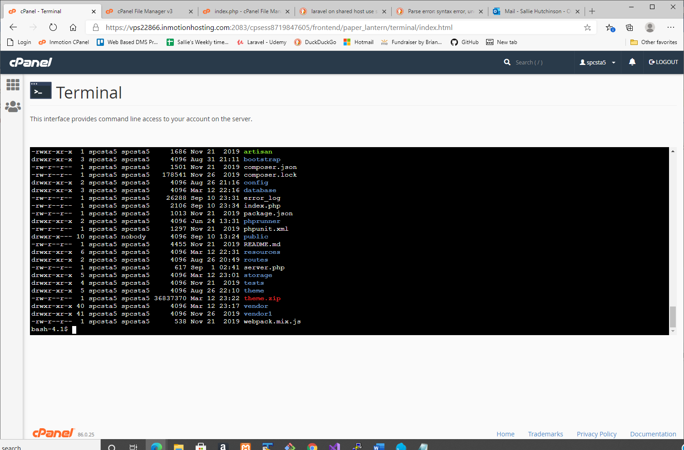
Another issue could be that the storage folder doesn't have the necessary permissions.According to what I have read:
Laravel may require some permissions to be configured: folders within storage and vendor require write access by the web server.
There is more info at this url
https://stackoverflow.com/questions/30639174/how-to-set-up-file-permissions-for-laravel
I didn't chmod the permissions because I don't want to overstep, but if it is ok, then I will.

