Hi Sallie,

Well so far here is what we have.

The website URL is star2020.spcstardoc.com or HTTP://157.230.58.165

Unlike InMotion this server is empty. I have installed Apache2, MySql, and PHP.

To get to the command prompt you need to open up Putty. Go to Session and fill in the Host Name like the one showing. Next, go down to Saved Sessions.
and type in star2020 and save. Next, see the 2nd image, you will need to go down to the SSH > Auth. Browse for your private key that you made Alex.

That will do it. Go back to the top "Session" and click on the "Open" button at the bottom.
The command prompt should open.

The MySql database is User root and password spconly.

I created this user.
CREATE USER 'admin'@'%' IDENTIFIED WITH mysql_native_password BY 'bobdutil';

I did create a DATABASE "test_db" to make sure it worked. You can delete it if you want.

I did this today.
https://www.digitalocean.com/community/tutorials/how-to-install-linux-apache-mysql-php-lamp-stack-on-ubuntu-20-04

This is like the Folder page we used on the CPanel. Still need to install
https://www.interserver.net/tips/kb/webmin-html-file-manager/
https://www.digitalocean.com/community/tutorials/how-to-install-webmin-on-ubuntu-20-04

Laravel Installation to do
https://www.digitalocean.com/community/tutorials/how-to-install-and-configure-laravel-with-nginx-on-ubuntu-20-04

Sincerely,
Robert B. Dutil
207-743-8197 Home
603-733-4241 Office

Hi Alex
I keep running into this kill issue when the project creation gets to the point of Updating dependencies. Bob said you use Digital Ocean a lot, and that you are very tech savvy (I don't remember his exact words, but that is what he meant) so I am hoping you may have some ideas. If not, then I will dig in tomorrow to research the issues.
Thanks,
Sallie

My research found 2 possible issues.
- Some articles suggest that there may not be enough memory for Laravel
  - I did clear the composer cache, but it didn't change things
  - Do you think we have enough memory?
- The command line gives the warning to not run Composer as root/super user
  - I created my own user and left superuser, but that didn't work either.

This error WAS due to insufficient memory.
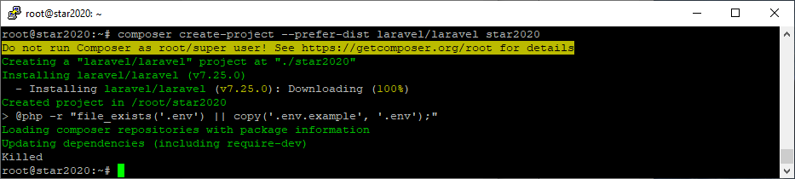

Helpful URLs
https://dev.to/rizwan_saquib/how-to-create-lamp-stack-with-laravel-on-digital-ocean-server
https://www.digitalocean.com/community/tutorials/how-to-install-linux-apache-mysql-php-lamp-stack-on-ubuntu-20-04
https://www.digitalocean.com/community/tutorials/how-to-install-and-configure-laravel-with-nginx-on-ubuntu-20-04
https://www.digitalocean.com/community/tutorials/how-to-deploy-a-laravel-application-with-nginx-on-ubuntu-16-04
https://learninglaravel.net/how-to-create-lamp-stack-with-laravel-on-digital-ocean-server

Where is the public_html folder where I can put the site files? I have just created a droplet. Can anyone guide me on this one? Thank you.
Well I know for apache, on ubuntu, its in the /var/www/ folder
__DIR__ is a "magic constant" in PHP 5.3 or above which always refers to the current directory of the file from which it is called.
It's a convenient way to reference a directory when using includes that may be located elsewhere in the file system.

In Laravel the path for serving your web page is in the /public folder. By default after installing Laravel and navigating in a browser to the URL you will see a directory listing of all the Laravel files. Here’s an easy way using an .htaccess file to redirect requests to the Laravel /public folder user mod_rewrite.
Create a .htaccess file in your root directory and add the following code.
RewriteEngine on
RewriteCond %{REQUEST_URI} !^public
RewriteRule ^(.*)$ public/$1 [L]
Save your file and refresh your browser, you should now see the default Laravel splash page.

Going to this url takes me to the laravel hierarchy
https://star2020.spcstardoc.com/

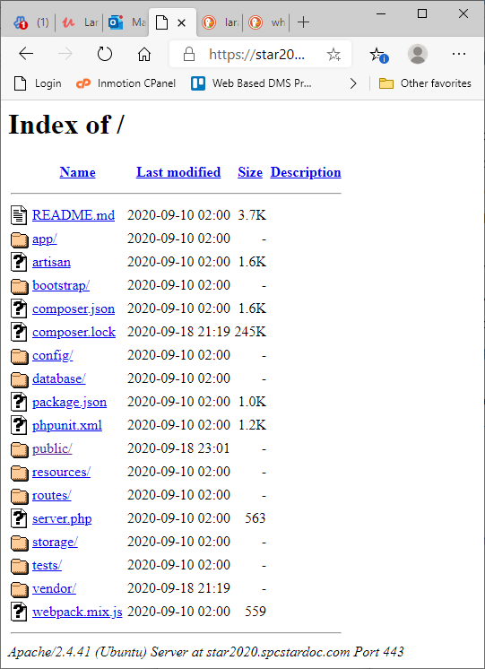

Going here takes me to an error page
https://www.star2020.spcstardoc.com/

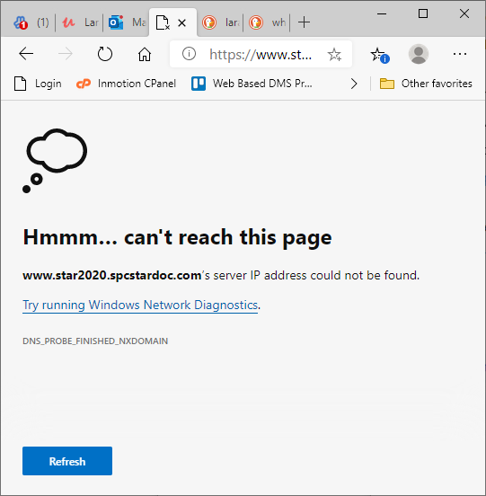

Going to either of these urls takes me to the index.php page in var/www/star2020/public/index.php
https://star2020.spcstardoc.com/public/index.php
https://star2020.spcstardoc.com/public/

By default Apache uses /var/www as document root.

https://codebyray.com/web-development/php/laravel/how-to-change-the-default-directory-structure-in-laravel/

How to change the default directory structure in Laravel
August 17, 2017 in Laravel
I have seen this asked many times on the Laravel forums as well as other discussion boards. Even found myself searching and looking for a way to change the default directory structure to use it on a VPS with WHM/Cpanel.
As many of you know the default public directory is public_html when running most VPS with WHM/CPanel. Which can be a pain to deploy to under the default directory structure if you do not have access to setup symlinks or know how for that matter.
During my search I have combined suggestions I have read into one. I hope this helps some of you who have struggled with this currently and in the past.

Part 1: Moving folders to the laravel folder
First create a new folder in your root directory named ‘laravel’ (or whatever you want to call it) and move all folders and files except the ‘public’ directory into it. And rename the ‘public’ folder to ‘public_html’.
After making this change the root directory should have changed from:
-app
-bootstrap
-config
-database
-public
-resources
-routes
-storage
-tests
-vendor
.env
.env.example
.gitattributes
.gitignore
artisan
composer.json
composer.lock
package.json
phpunit.xml
readme.md
server.php
webpack.mix.js
To the new structure:
-laravel
-app
-bootstrap
-config
-database
-resources
-routes
-storage
-tests
-vendor
.env
.env.example
.gitattributes
.gitignore
artisan
composer.json
composer.lock
package.json
phpunit.xml
readme.md
server.php
webpack.mix.js
-public_html

Part 2: Modify the public_html/index.php file and the laravel/server.php file
Open the public_html/index.php file in your favorite editor and make the following changes:
Change these lines from:
require __DIR__.'/../bootstrap/autoload.php';
$app = require_once __DIR__.'/../bootstrap/app.php';
To this:
require __DIR__.'/../laravel/bootstrap/autoload.php';
$app = require_once __DIR__.'/../laravel/bootstrap/app.php';
Now open the laravel/server.php file and make the following modifications:
Change these lines from:
if ($uri !== '/' && file_exists(__DIR__.'/public'.$uri)) {
return false;
}
require_once __DIR__.'/public/index.php';
To this:
if ($uri !== '/' && file_exists(__DIR__.'../public_html'.$uri)) {
return false;
}
require_once __DIR__.'../public_html/index.php';
With these changes you can now access the the index.php file and the site will work. But we still have the public_path issue which will need to be addressed.

Part 3: Fix issue with the public path
To fix the issue with calling public_path and it returning ‘laravel/public’ we need to create a new provider we can call it ConfigServiceProvider (note: This idea came from here: https://laracasts.com/discuss/channels/general-discussion/where-do-you-set-public-directory-laravel-5/replies/14105 I just changed the name from AppServiceProvider to ConfigServiceProvider).
Lets create the ConfigServiceProvider:
php artisan make:provider ConfigServiceProvider
Now open the newly created file located in app/Providers/ConfigServiceProvider and put the following content:
<?php
namespace App\Providers;
use Illuminate\Support\ServiceProvider;
class ConfigServiceProvider extends ServiceProvider
{
/**
* Bootstrap the application services.
*
* @return void
*/
public function boot()
{
//
}
/**
* Register the application services.
*
* @return void
*/
public function register()
{
$this->app->bind('path.public', function() {
return realpath('../public_html');
});
}
}
Now open your config/app.php file and add the newly created ConfigServiceProvider to the providers list:
App\Providers\ConfigServiceProvider::class,
Note: You should put this near the top so other parts of the system know the change was made.
Now run:
composer dump-auto
Check the public_path() function and you will now see it shows the new directory as intended ‘public_html’
If you want to store files in the public_html folder you can modify the config/filesystems.php file like so:
'public' => [
'driver' => 'local',
'root' => public_path('storage'),
'url' => env('APP_URL').'/storage',
'visibility' => 'public',
],
This would allow you to store files in the public_html/storage folder and access them via http://yourdomain.com/storage
I do not use mix but I am sure you would need to change the paths in the webpack.mix.js folder as well:
// From
mix.js('resources/assets/js/app.js', 'public/js')
.sass('resources/assets/sass/app.scss', 'public/css');
// To
mix.js('resources/assets/js/app.js', '../public_html/js')
.sass('resources/assets/sass/app.scss', '../public_html/css');
I hope this helps others looking to change the directory structure. If anyone has any other ways to accomplish this that will work better I would love to hear it.
Thank you for reading and your comments!
Regards,
Ray

On my machine - using localhost, I get this if I haven't done - - php artisan serve 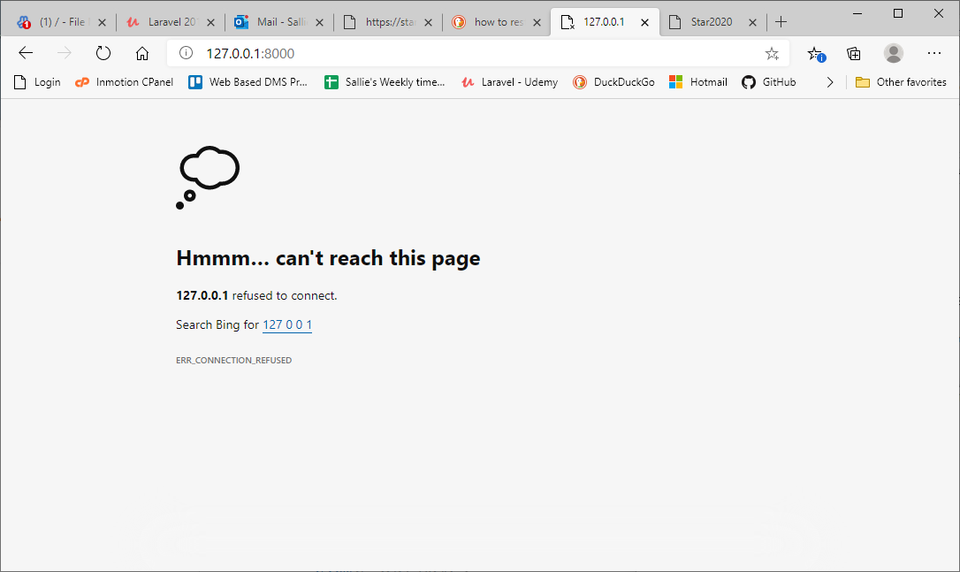

After doing - - php artisan serve, I get this
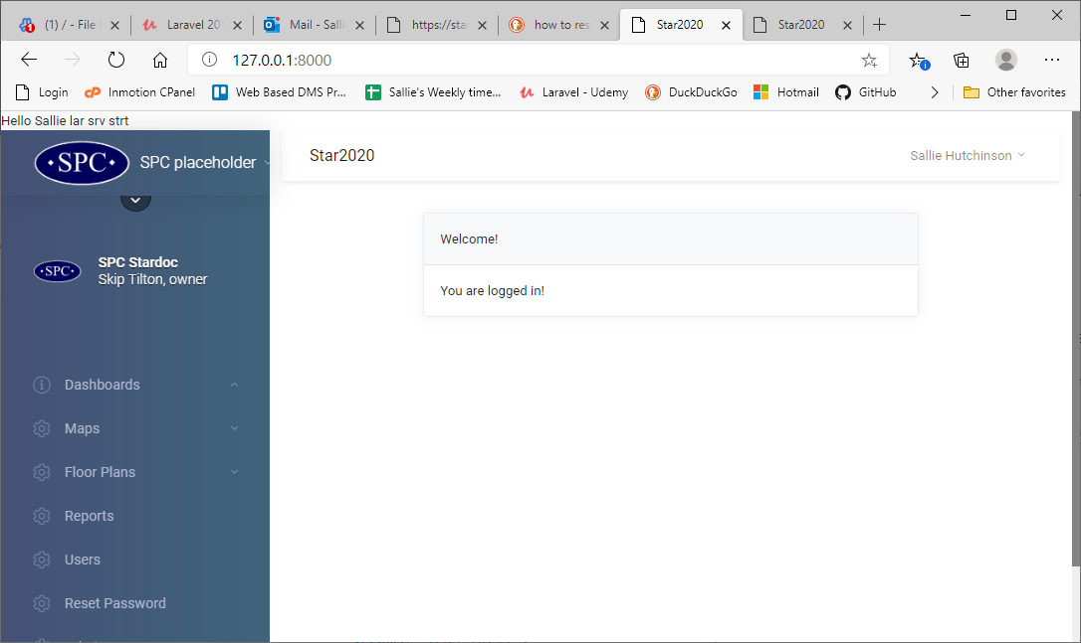

Permissions that were changed - - Maybe Alex can help us give group permissions, or something so I can revert these permissions to a higher level
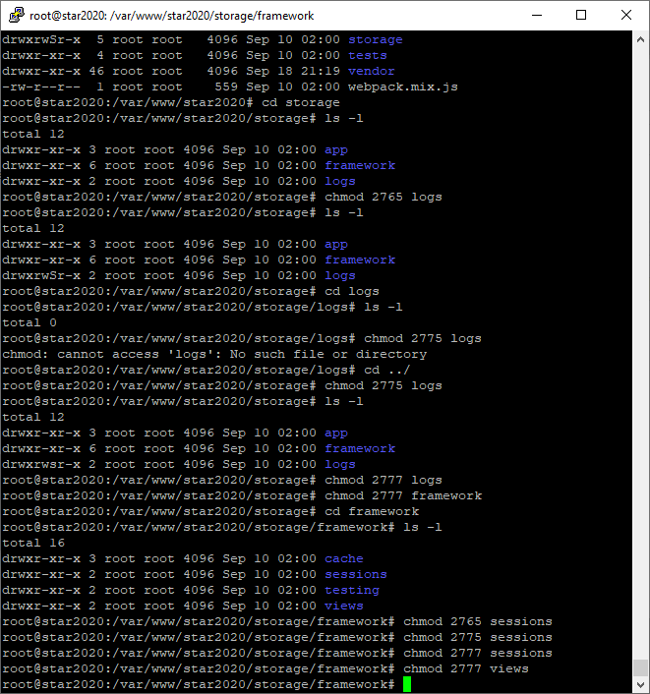

I get this error even though the permissions are correct
