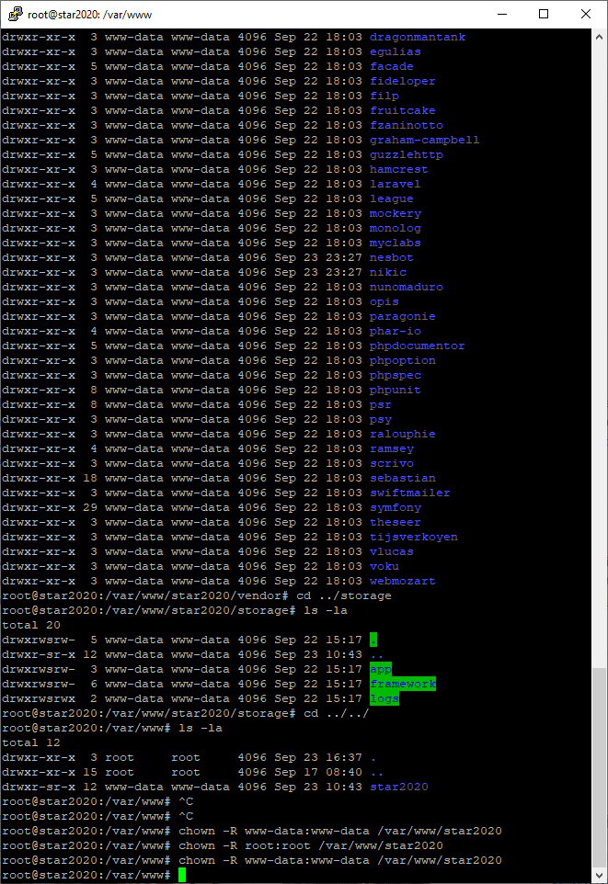
I kept running into permissions denial for vendor folder. I had to change the owner and group from root:root to www-data:www-data using chown -R www-data:www-data /var/www/star2020 from within the www folder. I still had errors, even though there was now nothing being written to either the error log or the access log.
Bob had only entered https://star2020.spcstardoc.com (without the preceding www) and it was displaying the welcome page. I removed the www from my url and It now works.
