Please follow these steps to reset your password to a more secure one with your email as your new user name.
- go to https://spcdms.net/star2020
- click the Forgot Your Password? Link

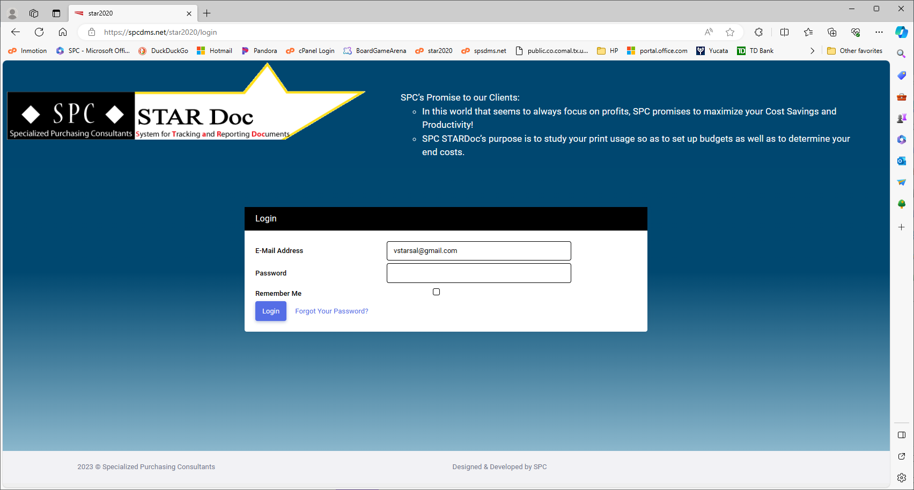

- You will be taken to the following page where you can enter your email address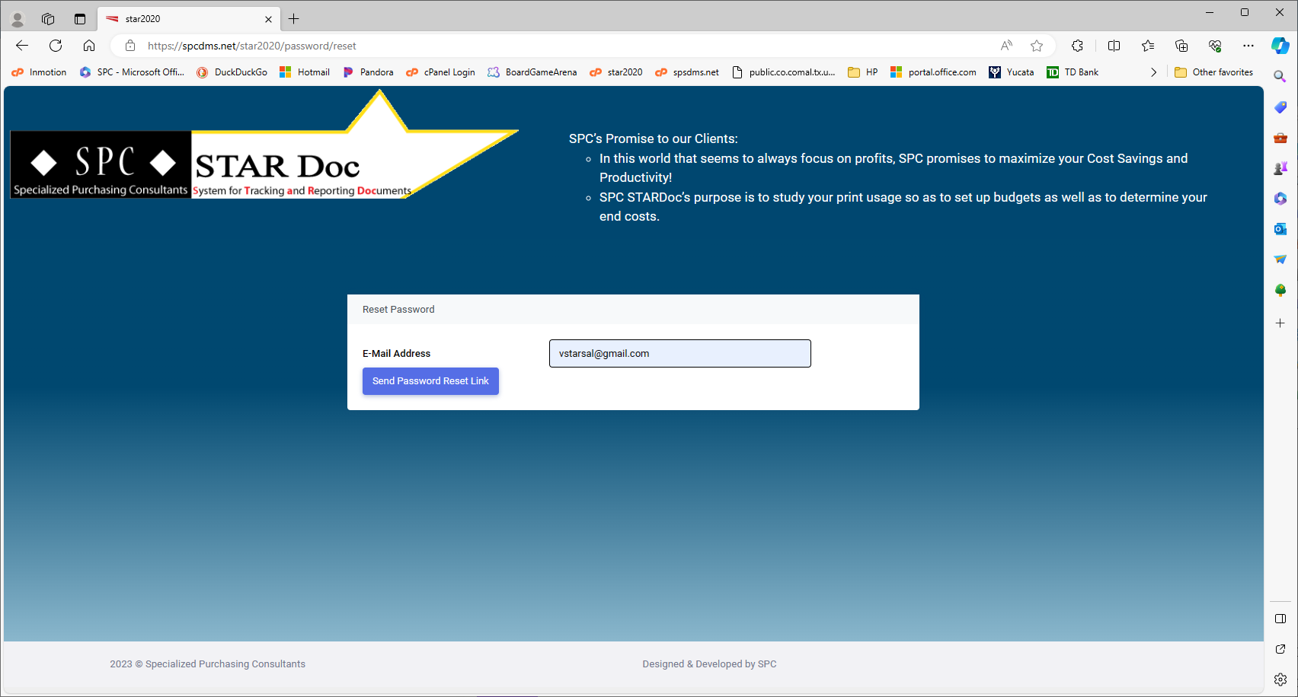

- Click Send Password Reset Link
- You will see this message that We have emailed your password reset link!
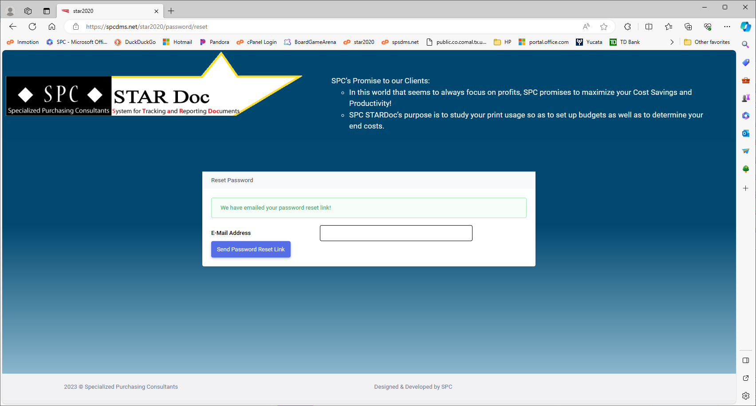
- Go to your email that you entered
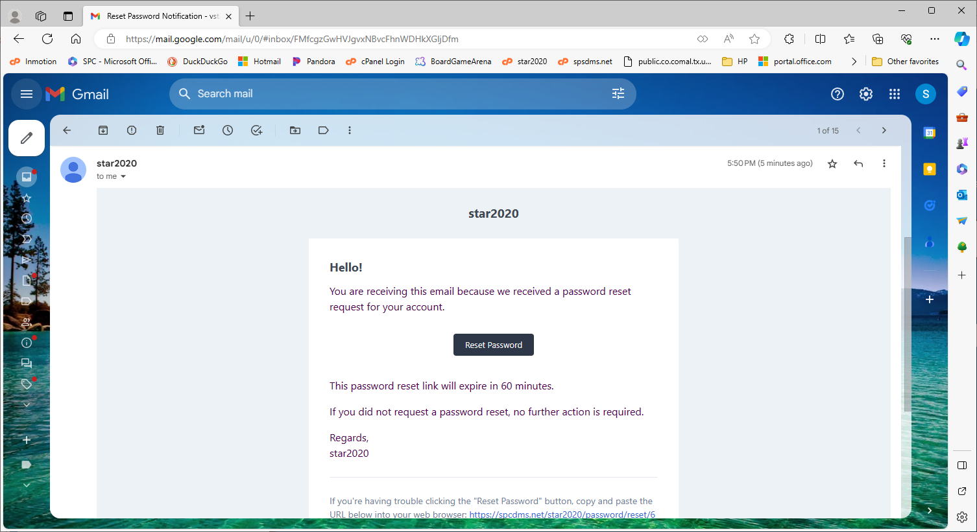
- Click the Reset Password Button and you will be taken to our Reset Password page
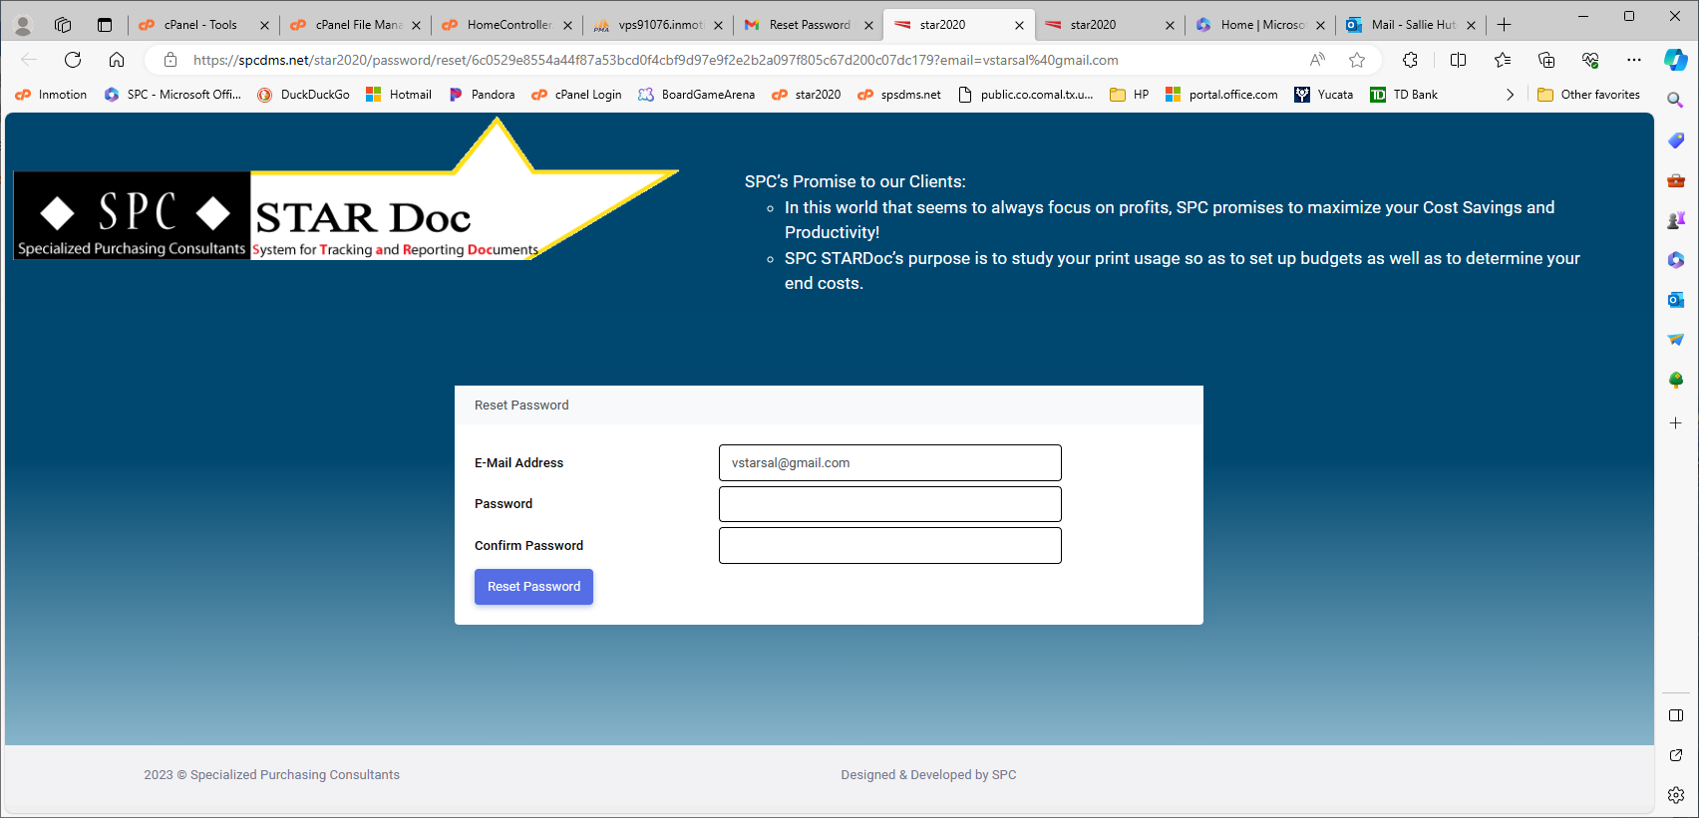

- Enter your password in both boxes, then click Reset Password. Passwords must meet these security requirements. They must contain:
  - at least 8 characters
  - at least one uppercase and one lowercase letter
  - at least one number
  - at least one symbol
- When your password has been successfully confirmed, you will then be taken to our home page.

