I tried replacing datatables with DataTables in hopes that colReorder and stateRestore would work.– 7/18/2022
BUT…. I found that by removing the 1st header row (one that holds the date) the colReorder now works.

(public/custom/plugins/DataTables

I got the download from Download (datatables.net)

App.blade.php – line 29
<link rel="stylesheet" media="screen, print" href="{{asset('custom/plugins/DataTables/datatables.min.css')}}">
Line 182
<script type="text/javascript" src="{{asset('custom/plugins/DataTables/datatables.min.js')}}"></script>

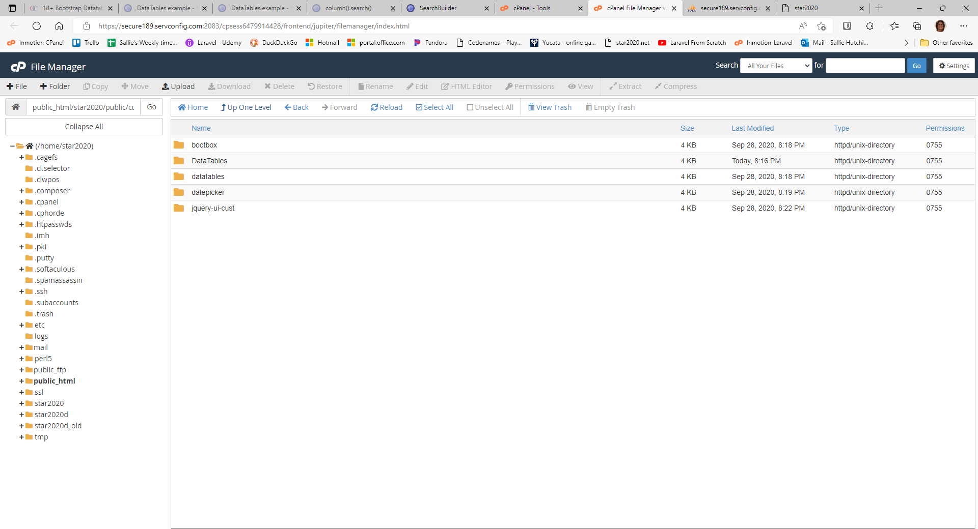

New folders
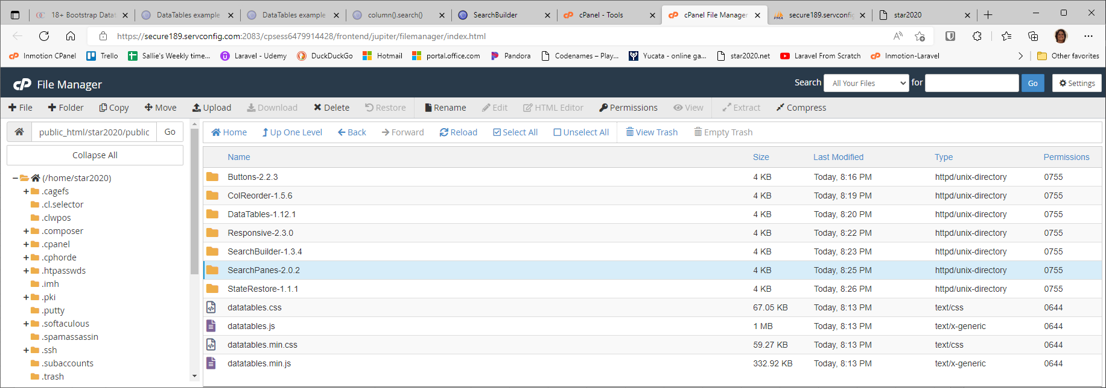
Js files imported
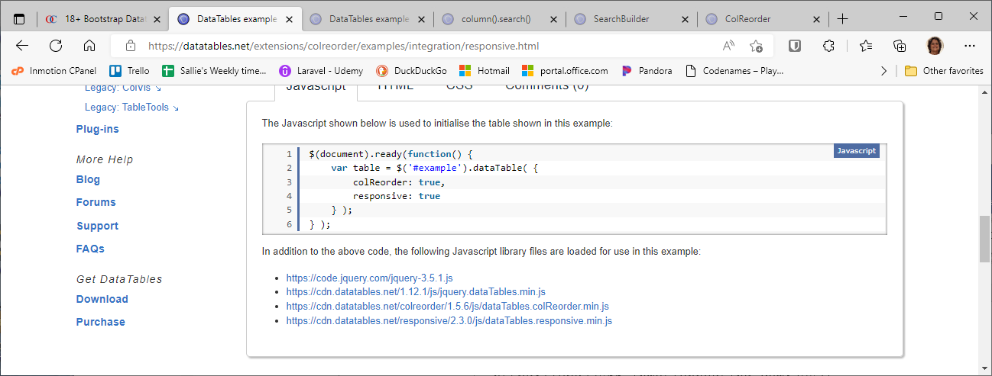

Css files imported
