Data scrubbing
- Building name in tblContacts is null, but the building id has a value that does have a name in buildings table. Should data be updated in the tblContacts table?
  - [Bob] No. No longer use Building Name. That was a Outlook thing. Need to link the building_id to the building table which will feed a drop down field.
- Where should contact_type from the dropdown be inserted into the tblContacts table? - Should it be org_user?
  - [Bob] This is another bandaid. (Client, Vendor, Other) should go into the ClientID field which was a spare field. They no longer used the ClientID so we used it for the contact_type.
- Currently the distinct org_user values are listed below - - (not just Client, Vendor, Other)
  - C
  - Client
  - Null
  - V
  - Vendor
  - N
- Business Phone in tblContacts
  - [Bob] I agree with what you listed below. That is a mess! I will have to talk to Alex & Pam about this. Once the new page and validations are set up they can audit the numbers.
  - numbers are underlined, while others are NOT underlined. None of them should be underlined
  - 1 has ext1 appended to the phone number (There is a separate column in this table called Bus_extension. This is where the ext 1 should be. Also(ext 441, 5, 30. 105, 112, 110, 108)
  - 1 has number of +1(800) 515-4242 - Is this correct, with the +1?
  - 1 has value of only 1213, 1 has only 207, 1294, 603692080 (There are ONLY 9 digits)
  - These may all be just test values - Some have no format with hyhens, like 6034358451
  - Bottom line - phone numbers should be stored as numbers ONLY, with no formatting. Formatting is done at the presentation level.
- Job Title in tblContacts has 303 DISTINCT values, BUT there are ONLY 9 job titles in the Job_Titles_tbl table. Do you still want me to pull the contact type for the accordion from the Job_Titles tbl? If so, the dropdown will be 303 rows in length.
  - [Bob] This is the table that is should pull from. The jt_id would be inserted into the “contact_types_sp” table.
  - 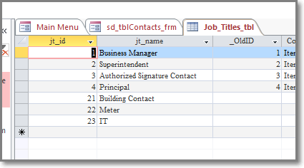
  - The “Job Title” can be anything that the user types in. This would be the job title that the customer refers too. The “jt_name” is the standard title that SPC uses internally for our reports.
State should be a dropdown and data should be scrubbed. There are values of sm, Te, Id, NULL. Te and sm are not even abbreviations for states. All state abbreviations should all be uppercased. (Data fix)
[Bob] Agreed.
- Org-id-contact in tblContacts table should be updated to be the id of the org in the organization table. When it is 0 or NULL in tblContacts it will NOT show in the upper panel.
  - [Bob] Agree. I spoke to Alex today about this. I will take care of updating it.

