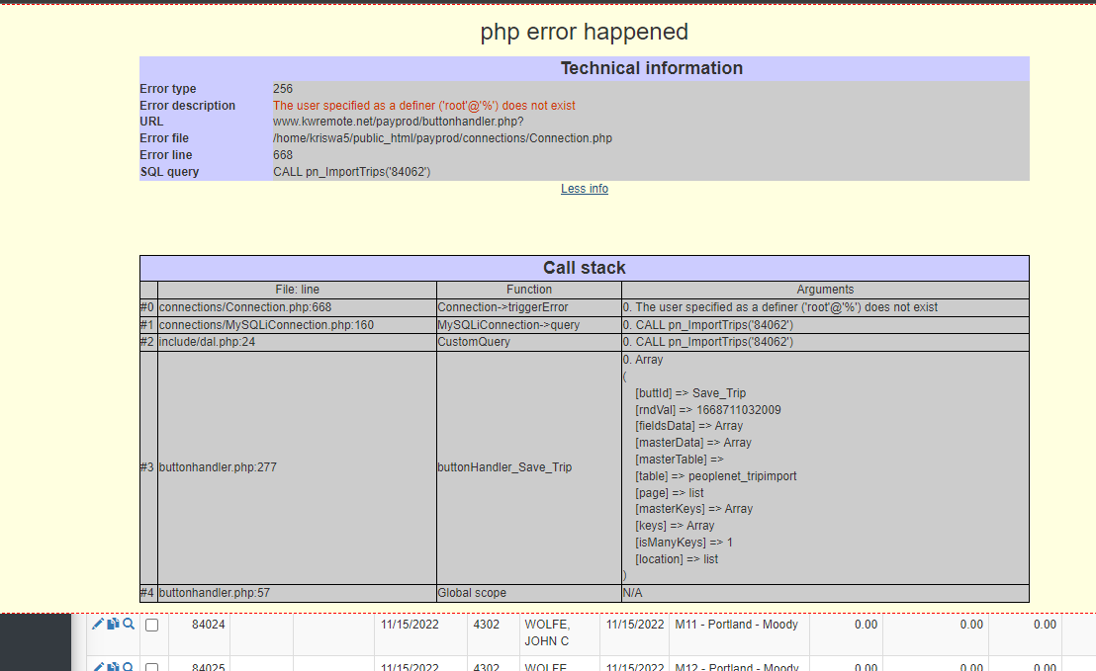
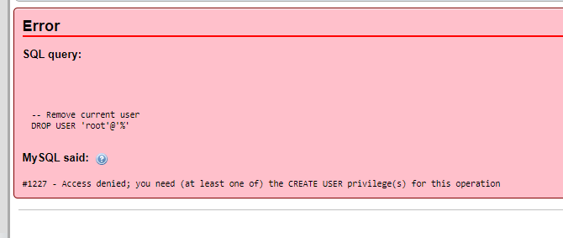
When my client tries to process their payroll they get the following error: "The user specified as a definer ('root'@'%') does not exist."
I understand to fix this I need to run the following Sql but I get access denied.
-- Remove current user
DROP USER 'root'@'%';
-- Add ROOT user again
CREATE USER 'root'@'%' IDENTIFIED BY 'ROOT_PASSWORD';
-- Add permissions
GRANT ALL PRIVILEGES ON * . * TO 'root'@'%';
FLUSH PRIVILEGES;
The resolution was to drop the procedure that had the definer listed as 'root'@'%' in the routines table of the information_schema, then to recreate them making the definer be `kriswa5`@`localhost`

Cpanel
https://secure189.servconfig.com:2083/logout/?locale=en
kriswa5
Bb36abVO6i

Grants for kriswa5_kwdp_test are
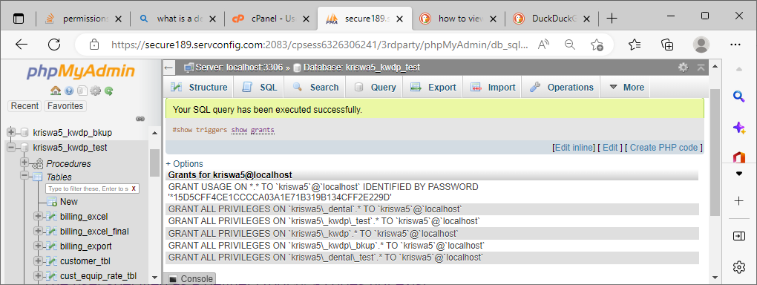
Users as shown in cPanel
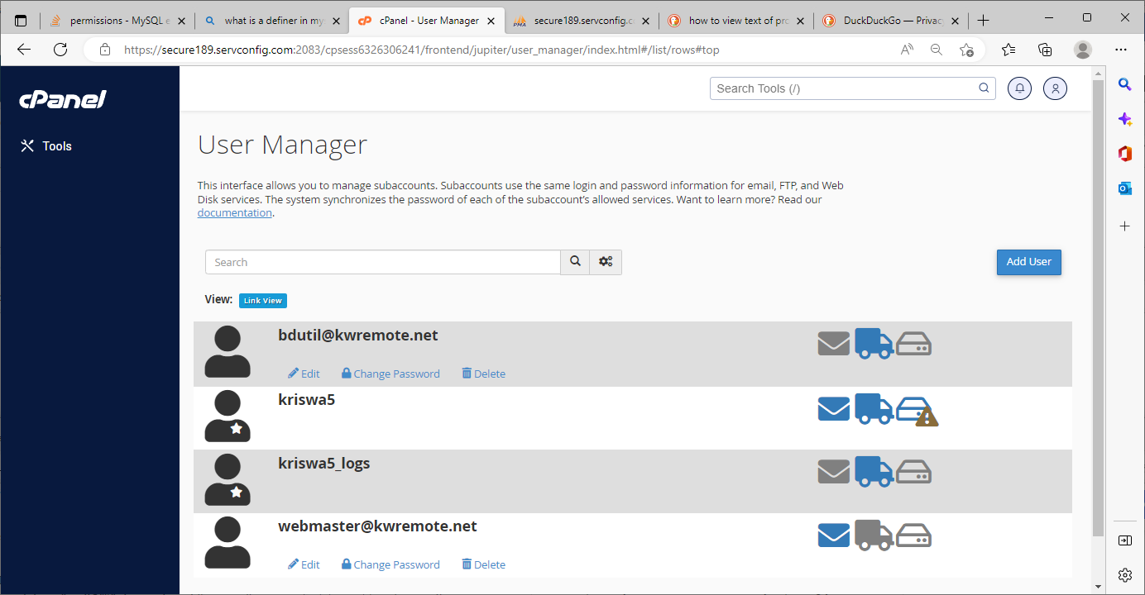

The proc that was causing the error:
DELIMITER $$
CREATE DEFINER=`kriswa5`@`localhost` PROCEDURE `pn_ImportTrips`(IN `var_import_id` INT(11))
proc_label:BEGIN
DECLARE var_start_date DATETIME;
DECLARE var_end_date DATETIME;
DECLARE var_master_trip_id INT(11);
DECLARE var_week_day INT;
DECLARE var_trip_exist INT;
DECLARE var_trans_id INT(11);

SELECT COUNT(trip_transaction_tbl.trans_dts), driver_trip_tbl.master_trip_id, trip_transaction_tbl.trans_id
INTO var_trip_exist, var_master_trip_id, var_trans_id
FROM (kriswa5_kwdp_test.peoplenet_tripimport peoplenet_tripimport
INNER JOIN
kriswa5_kwdp_test.trip_transaction_tbl trip_transaction_tbl
ON (peoplenet_tripimport.`Created on` =
trip_transaction_tbl.trans_dts))
INNER JOIN kriswa5_kwdp_test.driver_trip_tbl driver_trip_tbl
ON (trip_transaction_tbl.trip_master_id =
driver_trip_tbl.master_trip_id)
AND (peoplenet_tripimport.`Driver Id` = driver_trip_tbl.drv_id)
WHERE (peoplenet_tripimport.import_id = var_import_id);

UPDATE kriswa5_kwdp_test.peoplenet_tripimport b
SET b.master_id = var_master_trip_id,
b.trip_trans_id = var_trans_id
WHERE b.import_id = var_import_id;

IF var_trip_exist >0 Then
DELETE FROM kriswa5_kwdp_test.peoplenet_tripimport
WHERE import_id = var_import_id;
LEAVE proc_label;
END IF;

SELECT DAYOFWEEK(`Trip Date`) INTO var_week_day
FROM kriswa5_kwdp_test.peoplenet_tripimport
WHERE import_id = var_import_id;
IF var_week_day = 1 OR var_week_day = 2 OR var_week_day = 3 OR var_week_day = 4 OR var_week_day = 5 THEN
-- Friday
SELECT DATE_SUB(DATE_ADD(`Trip Date`, INTERVAL 0 - DAYOFWEEK(`Trip Date`) DAY), INTERVAL 1 DAY) INTO var_start_date
FROM kriswa5_kwdp_test.peoplenet_tripimport
WHERE import_id = var_import_id;
-- Thursday
SELECT DATE_SUB(DATE_ADD(`Trip Date`, INTERVAL 6 - DAYOFWEEK(`Trip Date`) DAY), INTERVAL 1 DAY) INTO var_end_date
FROM kriswa5_kwdp_test.peoplenet_tripimport
WHERE import_id = var_import_id;
ELSEIF var_week_day = 6 THEN
-- Friday
SELECT DATE_ADD(`Trip Date`, INTERVAL 0 + (DAYOFWEEK(`Trip Date`) - DAYOFWEEK(`Trip Date`)) * -1 DAY) INTO var_start_date
FROM kriswa5_kwdp_test.peoplenet_tripimport
WHERE import_id = var_import_id;
-- Thursday
SELECT DATE_ADD(`Trip Date`, INTERVAL 6 + (DAYOFWEEK(`Trip Date`) - DAYOFWEEK(`Trip Date`)) * -1 DAY) INTO var_end_date
FROM kriswa5_kwdp_test.peoplenet_tripimport
WHERE import_id = var_import_id;
ELSEIF var_week_day = 7 THEN
-- Friday
SELECT DATE_ADD(`Trip Date`, INTERVAL -1 + (DAYOFWEEK(`Trip Date`) - DAYOFWEEK(`Trip Date`)) * -1 DAY) INTO var_start_date
FROM kriswa5_kwdp_test.peoplenet_tripimport
WHERE import_id = var_import_id;
-- Thursday
SELECT DATE_ADD(`Trip Date`, INTERVAL 5 + (DAYOFWEEK(`Trip Date`) - DAYOFWEEK(`Trip Date`)) * -1 DAY) INTO var_end_date
FROM kriswa5_kwdp_test.peoplenet_tripimport
WHERE import_id = var_import_id;
END IF;

UPDATE kriswa5_kwdp_test.peoplenet_tripimport b, kriswa5_kwdp_test.trips_tbl a
SET b.`Trip Number` = a.trip_tbl_td
WHERE a.trip_number = b.`Trip Name`
AND b.import_id = var_import_id;

SELECT driver_trip_tbl.master_trip_id
INTO var_master_trip_id
FROM kriswa5_kwdp_test.driver_trip_tbl driver_trip_tbl
INNER JOIN kriswa5_kwdp_test.peoplenet_tripimport peoplenet_tripimport
ON (driver_trip_tbl.drv_id = peoplenet_tripimport.`Driver Id`)
WHERE (driver_trip_tbl.drv_trp_date = var_start_date)
AND (peoplenet_tripimport.import_id = var_import_id);

UPDATE kriswa5_kwdp_test.peoplenet_tripimport p
SET p.master_id = var_master_trip_id
WHERE p.import_id = var_import_id;

IF var_master_trip_id > 0 THEN
INSERT INTO kriswa5_kwdp_test.trip_transaction_tbl (
trip_master_id
, trans_trp_num
, trans_date
, trans_unit
, trans_delay_time
, trans_brkdown_time
, trans_dh
, trans_other
, t_wd_hours
, Note
, trans_dts)
SELECT master_id
,`Trip Number`
,`Trip Date`
, Vehicle
,`Delay Time`
,`Breakdown Time`
,`Stop Pay Time`
,`Other Time`
,`Total Hours Working-Driving`
, Remarks
,`Created on`
FROM kriswa5_kwdp_test.peoplenet_tripimport peoplenet_tripimport
WHERE import_id = var_import_id;
ELSE
INSERT INTO kriswa5_kwdp_test.driver_trip_tbl (drv_trp_date, drv_id, drv_trp_end_date)
SELECT var_start_date
AS LastFriday,
peoplenet_tripimport.`Driver Id`,
var_end_date AS Thursday
FROM kriswa5_kwdp_test.peoplenet_tripimport peoplenet_tripimport
WHERE import_id = var_import_id;
SELECT driver_trip_tbl.master_trip_id
INTO var_master_trip_id
FROM kriswa5_kwdp_test.driver_trip_tbl driver_trip_tbl
INNER JOIN kriswa5_kwdp_test.peoplenet_tripimport peoplenet_tripimport
ON (driver_trip_tbl.drv_id = peoplenet_tripimport.`Driver Id`)
WHERE (driver_trip_tbl.drv_trp_date = var_start_date)
AND (peoplenet_tripimport.import_id = var_import_id);
UPDATE kriswa5_kwdp_test.peoplenet_tripimport p
SET p.master_id = var_master_trip_id
WHERE p.import_id = var_import_id;
INSERT INTO kriswa5_kwdp_test.trip_transaction_tbl (
trip_master_id
, trans_trp_num
, trans_date
, trans_unit
, trans_delay_time
, trans_brkdown_time
, trans_dh
, trans_other
, t_wd_hours
, Note
, trans_dts)
SELECT master_id
,`Trip Number`
,`Trip Date`
, Vehicle
,`Delay Time`
,`Breakdown Time`
,`Stop Pay Time`
,`Other Time`
,`Total Hours Working-Driving`
, Remarks
,`Created on`
FROM kriswa5_kwdp_test.peoplenet_tripimport peoplenet_tripimport
WHERE import_id = var_import_id;
END IF;
UPDATE kriswa5_kwdp_test.settlement_hist a, kriswa5_kwdp_test.trip_transaction_tbl b
SET a.`Trip #` = b.trans_trp_num
WHERE (b.trans_id = a.trans_id);
UPDATE peoplenet_tripimport b, driver_trip_tbl a
SET b.master_id = a.master_trip_id
WHERE b.`Driver Id` = a.drv_id
AND var_start_date = a.drv_trp_date
AND b.import_id = var_import_id;
DELETE FROM kriswa5_kwdp_test.peoplenet_tripimport
WHERE import_id = var_import_id;
END$$
DELIMITER ;

