Will there ever be a time when the last meter read may not be the true one? I ask because in my testing I had an incorrect total, that kept being imported every time I imported into current_devices. That total was NOT the latest one, but it WAS the largest one.

The original query is
SELECT
MAX(m.black_meter) AS `black_end_meter`,
MAX(m.color_meter) AS `color_end_meter`,
MAX(m.date_timestamp) AS `last_date_time`,
cd.SerialNumber
FROM current_devices cd INNER JOIN meter m ON cd.SerialNumber = m.serial_number
WHERE cd.org_id_ma = 39
AND m.date_timestamp<=cd.EDate
GROUP BY cd.SerialNumber;

The record for the ser # returning different results is below
black_end_meter color_end_meter last_date_time SerialNumber
47779 55863 2019-05-24 20:10:26 MX4314862

Removing MAX from the 2 meter values results in the wrong volumes being returned
SELECT
m.black_meter AS `black_end_meter`,
m.color_meter AS `color_end_meter`,
MAX(m.date_timestamp) AS `last_date_time`,
cd.SerialNumber
FROM current_devices cd INNER JOIN meter m ON cd.SerialNumber = m.serial_number
WHERE cd.org_id_ma = 39
AND m.date_timestamp<=cd.EDate
GROUP BY cd.SerialNumber;

The record for the same ser # still returns incorrect results with this query
black_end_meter color_end_meter last_date_time SerialNumber
12390 9830 2019-05-24 20:10:26 MX4314862

This query uses an INNER JOINED subselect and returns the LATEST meter read instead of the LARGEST.
SELECT
m.black_meter AS `black_end_meter`,
m.color_meter AS `color_end_meter`,
s_num.dts AS `last_date_time`,
cd.SerialNumber

FROM current_devices cd
INNER JOIN meter m ON cd.SerialNumber = m.serial_number
INNER JOIN (SELECT MAX(date_timestamp) dts, serial_number FROM meter GROUP BY serial_number) s_num
ON s_num.serial_number = m.serial_number AND s_num.dts = m.date_timestamp
WHERE cd.org_id_ma = 39
AND s_num.dts <= cd.EDate
GROUP BY cd.SerialNumber;

The record for the same ser # still returns incorrect results with this query
black_end_meter color_end_meter last_date_time SerialNumber
43296 49419 2019-05-24 20:10:26 MX4314862

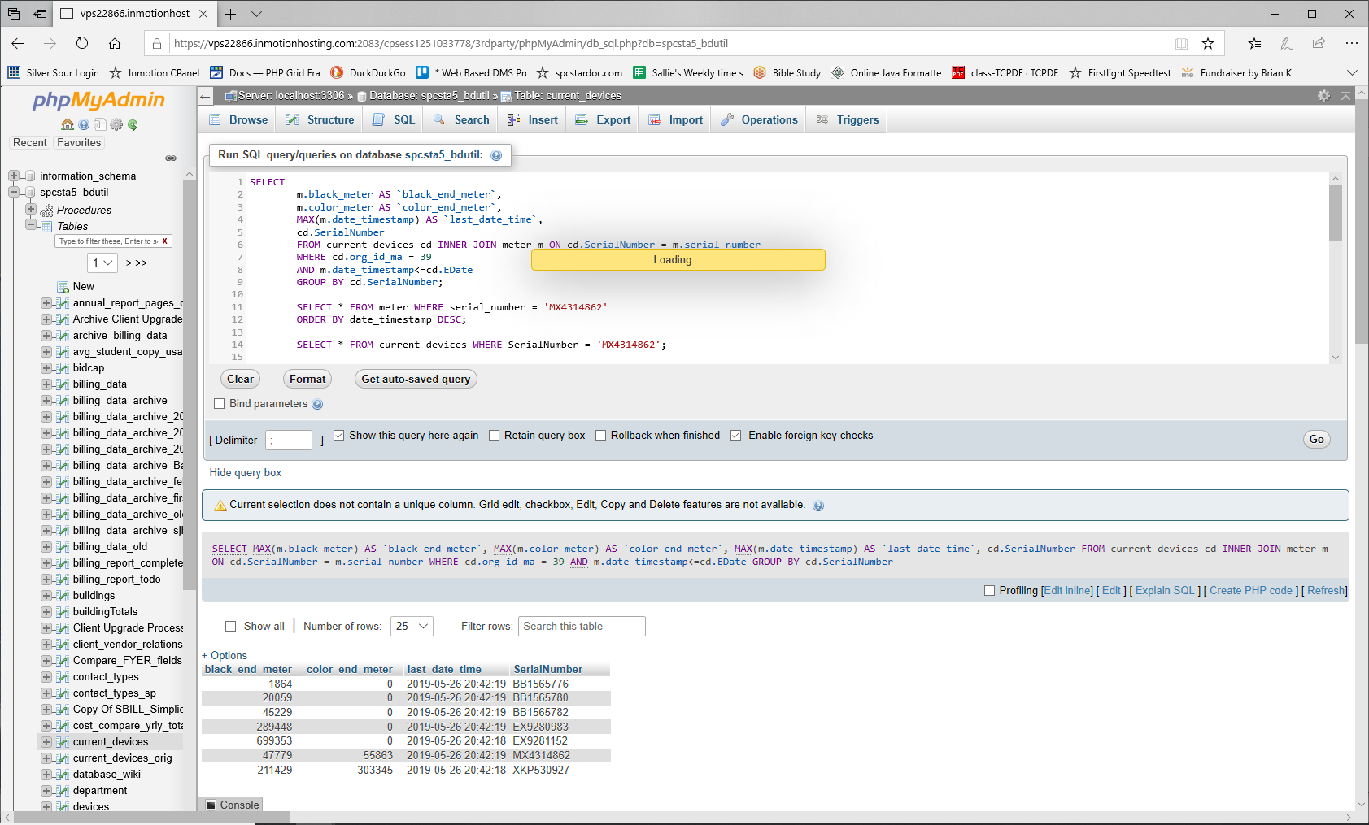

The first record in this resultset is the most current date_timestamp, along with the end meter values that were read on that date.
SELECT * FROM meter WHERE serial_number = 'MX4314862'
ORDER BY date_timestamp DESC;

black_end_meter color_end_meter last_date_time SerialNumber
43296 49419 2019-05-24 20:10:26 MX4314862

This query returns the max black end meter for the ser #
SELECT MAX(black_meter) FROM meter WHERE serial_number = 'MX4314862';
black_end_meter
47779

This query returns the max color end meter for the ser #
SELECT MAX(color_meter) FROM meter WHERE serial_number = 'MX4314862';
color_end_meter
55863

