Weird issue possibly caused by integrating DataTables Buttons with the DataTable.
The footer row would NOT style using my styles. I created these styles:
#myDataTable tfoot tr td{
background-color:#ced5e8;
text-align:right;
}
In looking at the styles in dev tools I found that they were not using <td> in the footer <tr>, but were using <th> instead. So. . . I changed my styles to th instead of td and now it works.

#myDataTable tfoot tr td{
background-color:#ced5e8;
text-align:right;
}

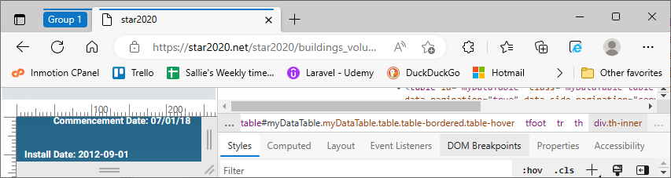

While loading, the table is a jQuery table? without DataTables styling, but after load it has the DataTables styling.
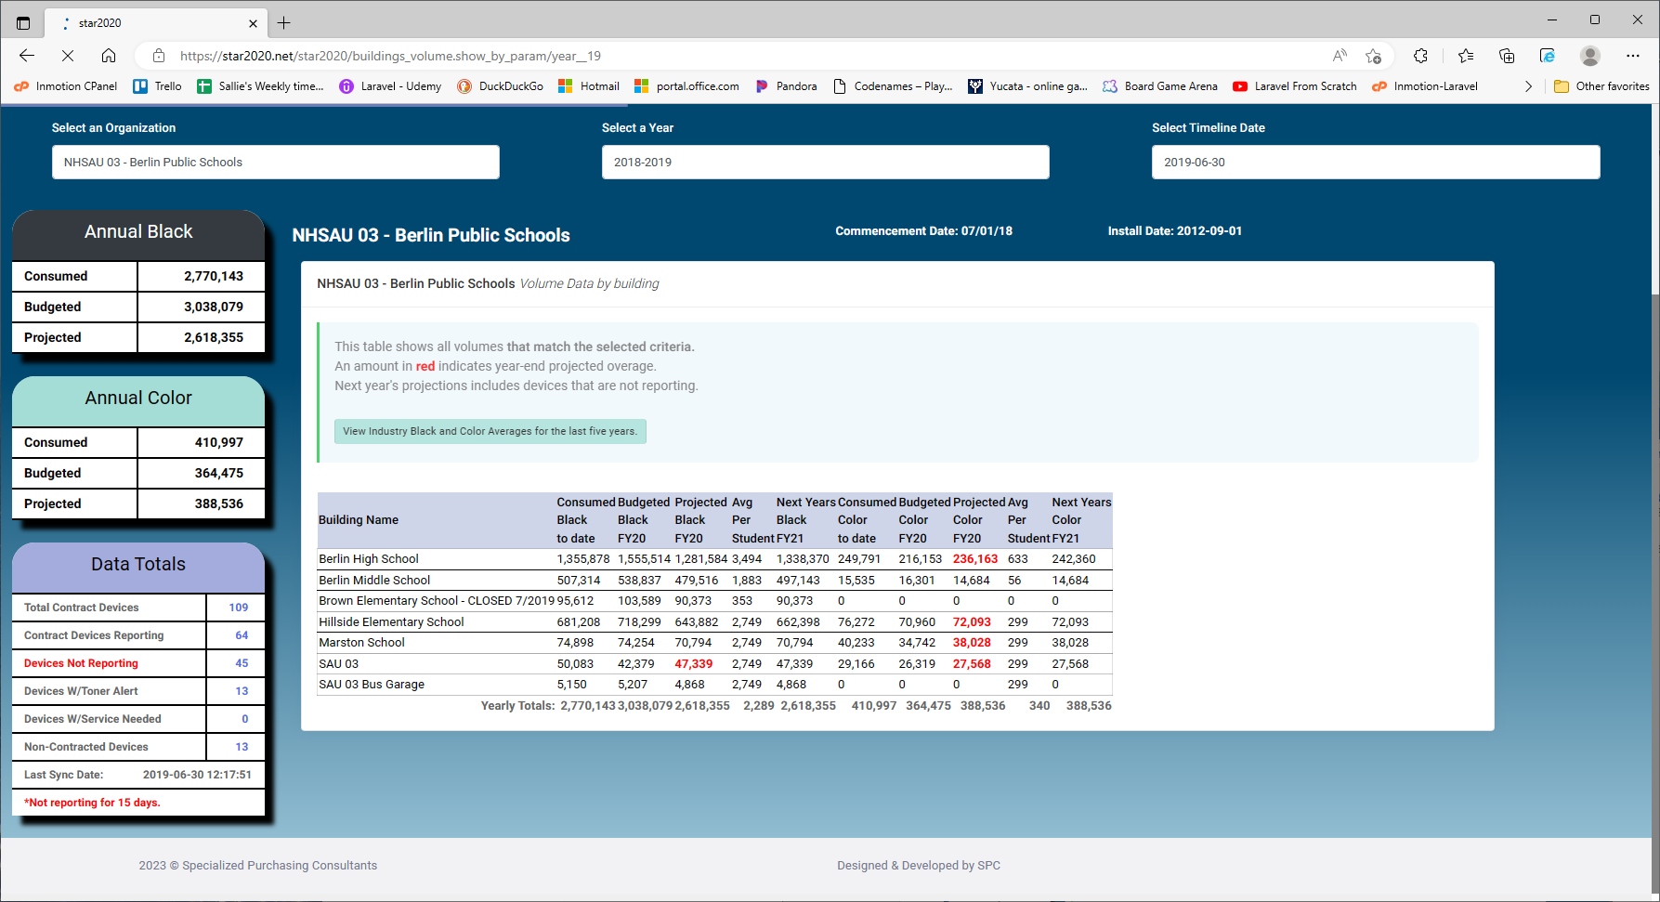
When clicking the Projected Black header column, the Yearly Totals footer is shown alternately with these 3 buildings only (Berlin High, Hillside, Berlin Middle).
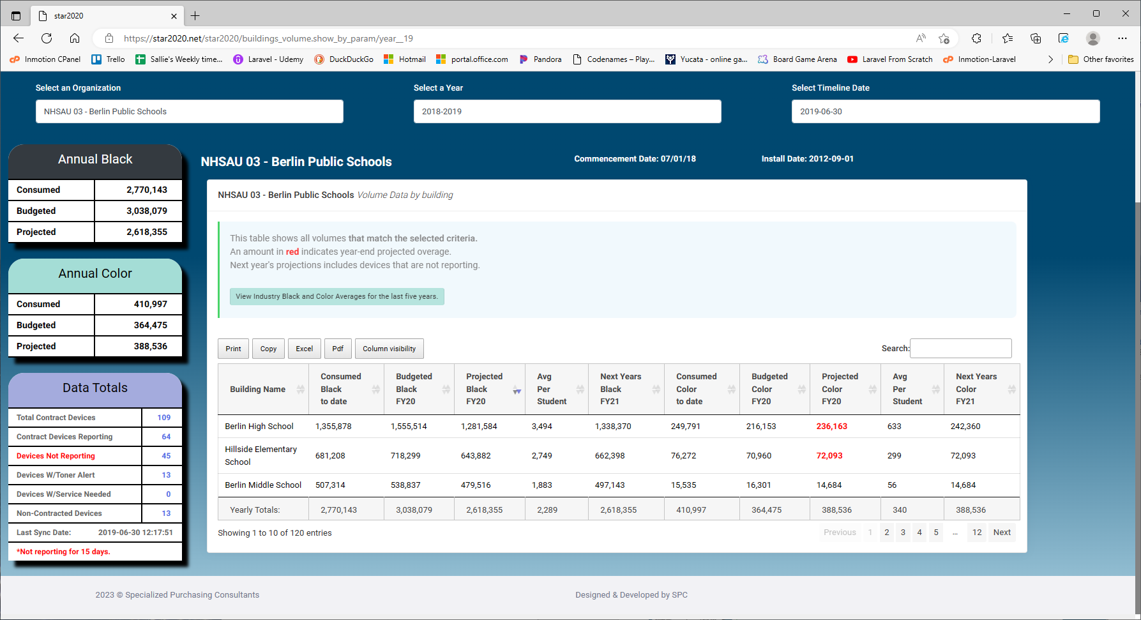
With Projected Black moved to follow Avg Per Student, their behaviors have switched. Avg Per Student now only shows the Yearly Totals footer row alternately with the same 3 buildings (Berlin High, Hillside, Berlin Middle). But clicking the Projected Black alternates between displaying the Yearly Totals and the entire building list of 7 buildings.
