Hi Alex
When I go to this page I click the Execute SQL button on the right.
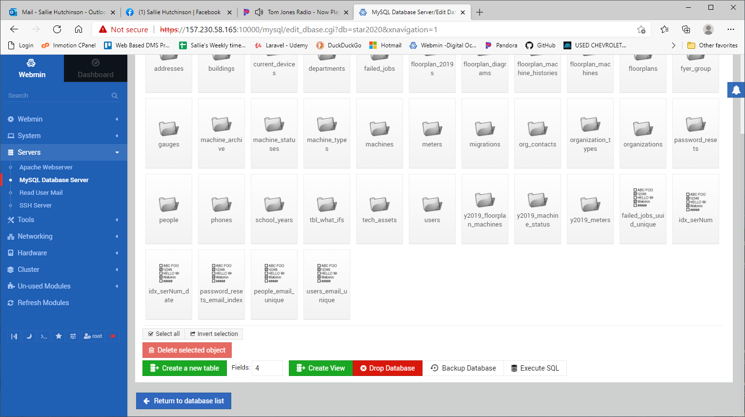

When I click Execute SQL the window below opens. There is no button to Execute after entering the SQL commands. There was an Execute button before, but not anymore. A few times the button reappeared after rebooting, but no longer. I checked to see if we have the latest version and it seems that we do. I was thinking that there may be a needed update, but I have been keeping the updates installed.
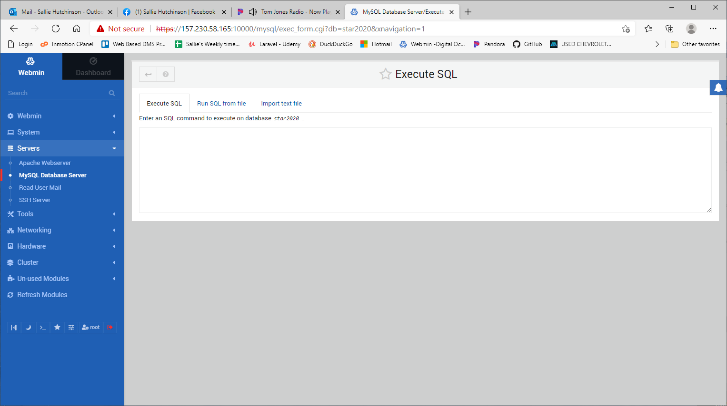
Here is a sample list of data I am trying to insert, but there is no issue with the actual insert. I have no issues inserting when the button is there, except that sometimes it takes a while for the page to open.
INSERT INTO `y2019_meters` (`id`, `serial_number`, `machine_id`, `black_meter`, `color_meter`, `created_date`, `created_by`, `modified_date`, `modified_by`) VALUES
(11012918, 'A0PP011007977', 9137, 1275978, 0, '2018-10-09 11:14:33', 1271, '2018-10-09 11:14:33', 1271),
(11012916, 'XVB8505761', 9120, 60069, 0, '2018-10-09 11:14:33', 1271, '2018-10-09 11:14:33', 1271),
(11012915, 'A0R5011012197', 9111, 531261, 0, '2018-10-09 11:14:33', 1271, '2018-10-09 11:14:33', 1271),
(11012914, 'A0DX013004583', 9123, 54714, 0, '2018-10-09 11:14:33', 1271, '2018-10-09 11:14:33', 1271);

The first sentence in your screenshot says that the
System information disabled due to load higher than 1.0.
What does this mean?
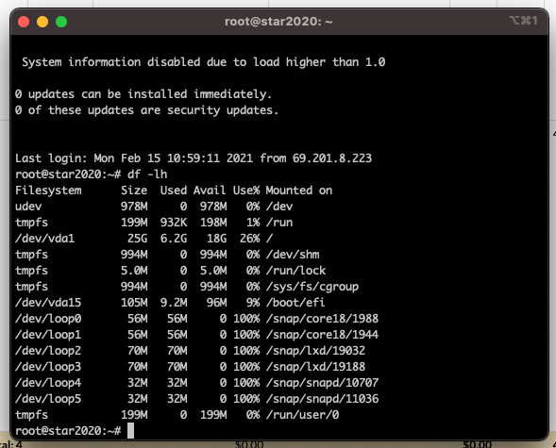

I'd hate to start all over again with the configurations to move to linode. It would be better to get this fixed. I will do some more research to see if I can find an answer.

Thanks,
Sallie

