Output directory window

NOTE: Make sure WAMP server is running or page will NOT be reached.
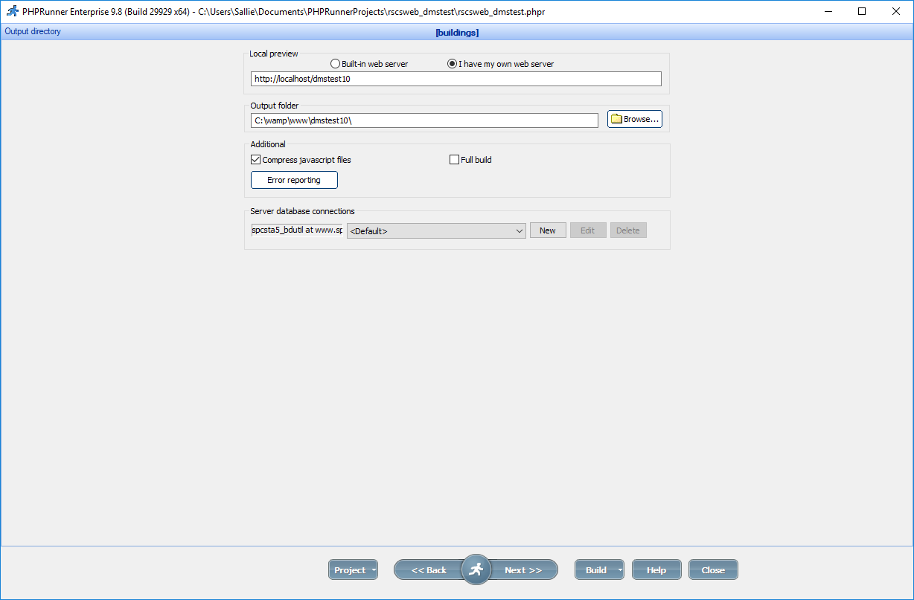

http://localhost/dmstest10/login.php
http://localhost/dmstest10/images/spcHeader.png

Change connection data in the dmstest10 folder
