These are the SQLs that Alex created in Access to work on the STARDoc tables.
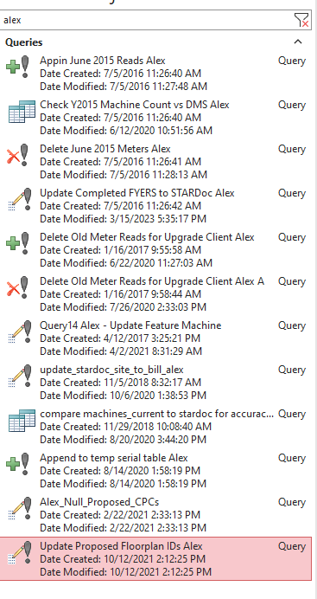

Update Proposed Floorplan IDs Alex
UPDATE floorplan_machines SET floorplan_machines.x_position = [floorplan_machines].[present_x_position]
, floorplan_machines.y_position = [floorplan_machines].[present_y_position]
WHERE (((floorplan_machines.save_name_id)=[Enter Save Name ID]));

Alex_Null_Proposed_CPCs
UPDATE tblWhatIf SET tblWhatIf.NewColorCPC = Null
, tblWhatIf.PropCost = Null
, tblWhatIf.vendor_black_cpc_proposed = Null
, tblWhatIf.vendor_color_cpc_proposed = Null
WHERE (((tblWhatIf.save_name_id)=[Enter Save Name ID]));

Append to temp serial table Alex
INSERT INTO temp_old_serial_numbers ( save_name_id
, SerialNum )
SELECT tblWhatIf.save_name_id
, tblWhatIf.SerialNum
FROM tblWhatIf
WHERE (((tblWhatIf.save_name_id)=[Enter Save Name ID]));

compare machines_current to stardoc for accuracy alex
SELECT Machines.org_id_ma
, Machines.SerialNumber AS [DMS Serial]
, floorplan_machines.serial_number AS [StaDoc Serial]
, Machines.Begin
, floorplan_machines.commencement_black_meter
, Machines.MstrBegin
, floorplan_machines.commencement_color_meter
, Machines.CostCopy
, floorplan_machines.cpc_black
, Machines.Mstrcpc
, floorplan_machines.cpc_color
, Machines.Anticipated
, floorplan_machines.budgeted_blk
, Machines.ProjColorVol
, floorplan_machines.budgeted_color
, floorplan_machines.commencement_date
FROM Machines LEFT JOIN floorplan_machines ON Machines.SerialNumber = floorplan_machines.serial_number
WHERE (((Machines.org_id_ma)=[Forms]![frmMachines_ALL]![txtOrgId]));

update_stardoc_site_to_bill_alex
UPDATE floorplan_machines INNER JOIN Machines ON floorplan_machines.serial_number = Machines.SerialNumber SET floorplan_machines.budgeted_blk = [machines].[Anticipated]
, floorplan_machines.budgeted_color = [machines].[ProjColorVol]
, floorplan_machines.cpc_black = [machines].[CostCopy]
, floorplan_machines.cpc_color = [machines].[Mstrcpc]
, floorplan_machines.commencement_black_meter = [machines].[Begin]
, floorplan_machines.commencement_color_meter = [machines].[MstrBegin]
, floorplan_machines.is_proposed = "Y"
, floorplan_machines.under_contract = "Y"
WHERE (((Machines.org_id_ma)=[Enter Org ID]) AND ((floorplan_machines.save_name_id)=[Enter Save Name ID on STARDoc]));

Query14 Alex - Update Feature Machine
UPDATE tblWhatIf INNER JOIN Machines ON tblWhatIf.NewSerialNum = Machines.SerialNumber SET Machines.Features = Right([1stYearEquipment]
,Len([1stYearEquipment])-InStr(1
,[1stYearEquipment]
,"~")-1)
WHERE (((tblWhatIf.save_name_id)=1573) AND ((Machines.org_id_ma)=112));

Delete Old Meter Reads for Upgrade Client Alex A
DELETE meter.*
FROM temp_old_serial_numbers INNER JOIN meter ON temp_old_serial_numbers.SerialNum = meter.serial_number

Old Meter Reads for Upgrade Client Alex
INSERT INTO temp_old_serial_numbers ( save_name_id
, SerialNum )
SELECT tblWhatIf.save_name_id
, tblWhatIf.SerialNum
FROM tblWhatIf
WHERE (((tblWhatIf.save_name_id)=1546));

Update Completed FYERS to STARDoc Alex
UPDATE floorplan_machines INNER JOIN tblWhatIf ON floorplan_machines.id = tblWhatIf.fpm_id SET floorplan_machines.model_id = [tblWhatIf].[proposed_model_id]
, floorplan_machines.serial_number = [tblWhatIf].[NewSerialNum]
, floorplan_machines.new_vendor_device_id = [tblWhatIf].[NewVendorID]
, floorplan_machines.budgeted_blk = [tblWhatIf].[PropVol]
, floorplan_machines.budgeted_color = [tblWhatIf].[ProjColorVol]
, floorplan_machines.cpc_black = [tblWhatIf].[PropCost]
, floorplan_machines.cpc_color = [tblWhatIf].[NewColorCPC]
, floorplan_machines.commencement_black_meter = [tblWhatIf].[commencement_blk_meter]
, floorplan_machines.commencement_color_meter = [tblWhatIf].[commencement_color_meter]
, floorplan_machines.present_serial_number = [tblWhatIf].[SerialNum]
, floorplan_machines.present_model_id = [tblWhatIf].[present_model_id]
, floorplan_machines.room_number = [tblWhatIf].[proposed_room_number]
, floorplan_machines.present_room_number = [tblWhatIf].[present_room_number]
, floorplan_machines.floorplan_id = [tblWhatIf].[proposed_floorplan_id]
, floorplan_machines.present_floorplan_id = [tblWhatIf].[present_floorplan_id]
, floorplan_machines.[5_year_id] = [tblWhatIf].[map_id]
WHERE (((tblWhatIf.save_name_id)=[Enter Save Name ID]) AND ((floorplan_machines.save_name_id)=[Enter Save Name ID]));

Delete June 2015 Meters Alex
DELETE DISTINCTROW Y2015_meter.*
, Y2015_floorplan_machines.save_name_id
, Y2015_meter.date_timestamp
FROM Y2015_meter INNER JOIN Y2015_floorplan_machines ON (Y2015_meter.machine_id = Y2015_floorplan_machines.id) AND (Y2015_meter.serial_number = Y2015_floorplan_machines.serial_number)
WHERE (((Y2015_floorplan_machines.save_name_id)=[Enter Save Name ID]) AND ((Y2015_meter.date_timestamp)>#6/10/2015#));

Check Y2015 Machine Count vs DMS Alex
SELECT Machines.org_id_ma
, Y2015_floorplan_machines.save_name_id
, Machines.SerialNumber
, Y2015_floorplan_machines.serial_number
, Y2015_floorplan_machines.is_proposed
, Y2015_floorplan_machines.under_contract
, Y2015_floorplan_machines.floorplan_id
FROM Machines LEFT JOIN Y2015_floorplan_machines ON Machines.SerialNumber = Y2015_floorplan_machines.serial_number
WHERE (((Machines.org_id_ma)=[Enter Org ID]) AND ((Y2015_floorplan_machines.save_name_id)=[Enter Save Name ID]));

June 2015 Reads Alex
INSERT INTO Y2015_meter ( black_meter
, color_meter
, machine_id
, date_timestamp
, serial_number )
SELECT Machines.end
, Machines.MstrEnd
, Y2015_floorplan_machines.id
, #6/30/2015# AS Expr1
, Y2015_floorplan_machines.serial_number
FROM Machines INNER JOIN Y2015_floorplan_machines ON Machines.SerialNumber = Y2015_floorplan_machines.serial_number
WHERE (((Machines.org_id_ma)=[Enter Org ID]) AND ((Y2015_floorplan_machines.save_name_id)=[Enter SN ID]));

